1. OneWebSQL
OneWebSQL (http://onewebsql.com/homepage) is an Object Relational Mapping (ORM) library and set of tools that serves transparent access layer between Java and database.
OneWebSQL provides also set of tools to generate Java classes for database entities.
The generated classes have set of methods for CRUD (Create, read, update, delete) operations.
It comes in 4 different distributions. In this document we present OneWebSQL for JDBC distribution.

2. Spring Bootstrap project

Spring bootstrap project is a kick-off Spring MVC setup from which we will start integration with OneWebSQL. At the beginning the project does not have ORM layer connected. It can be downloaded from gihub: https://github.com/piczmar/onewebsql/tree/base_spring_mvc
or using git command:

On base of this in next steps we will add OneWebSQL layer and create exemplary application which is simple social portal. It will enable user to:
- register
- login to system
- publish his achievements on his wall in a form like:
On 20/02/2012 I became Java professional programmer and it was SIMPLE
- earn points for each achievement depending on how difficullt the task was
- see what other users published and like their posts

3. Install PostgreSQL database
The database setup is out of scope of this document, please refer to PostgreSQL documentation.
Here we will create new database schema and load some demo data.
Open PostgreSQL Admin (pgAdmin III) console and connect to your local database.
Create new schema onewebsql.
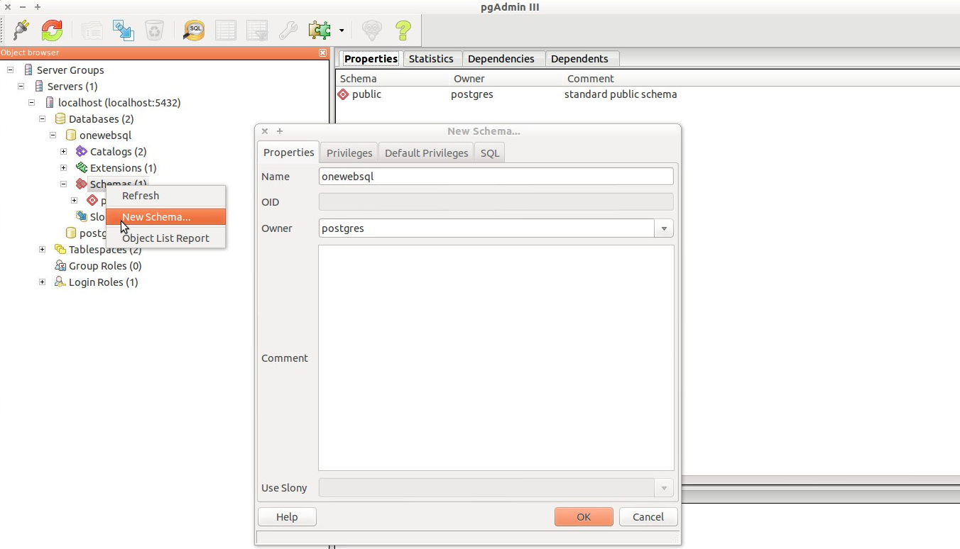
In pgAsmin pen database model sql file attached to this document (db_model.sql).
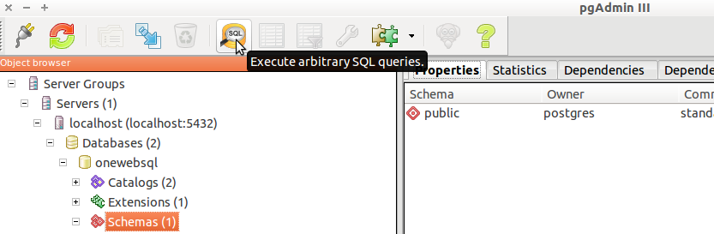

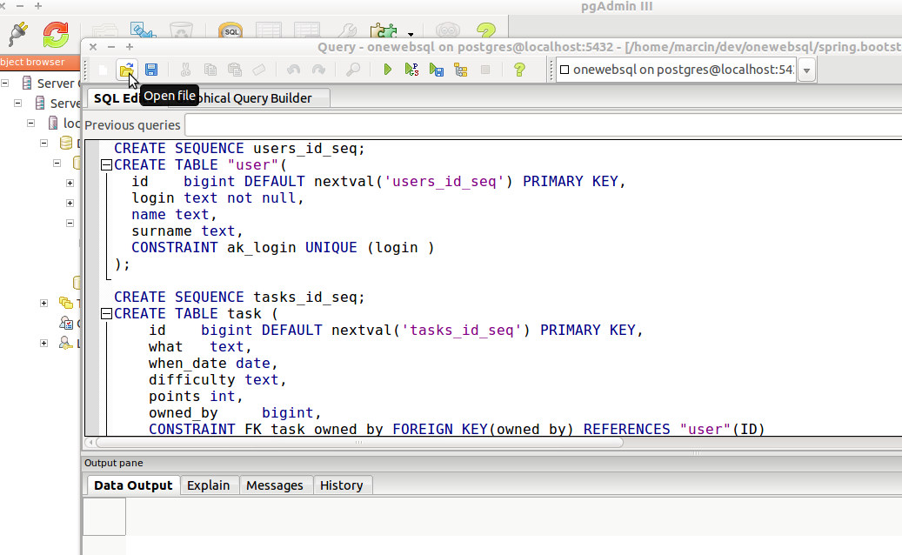
Run the file.
This will create new schema and populate with demo data.

4. Install OneWebSQL

We will install OneWebSQL with Maven.
Demo application was developed and tested using Maven version:
Apache Maven 3.0.4 (r1232337; 2012-01-17 09:44:56+0100)

More details on how to install OneWebSQL can be found at http://onewebsql.com/docs/1_0_x/official/onewebsql-db2java-install-guide/onewebsql-db2java-install-guide.html

In short:
- download and extract package onewebsql-db2java-1.0.3
- in command line:
cd onewebsql-db2java-1.0.3
./install

This will add OneWebSQl jars to your local maven repository.

- add to your project pom.xml the following dependency:

<dependency>
<groupId>com.onewebsql</groupId>
<artifactId>onewebsql-runtime</artifactId>
<version>1.0.3</version>
</dependency>

dependency for PostgreSQL driver:
<dependency>
<groupId>postgresql</groupId>
<artifactId>postgresql</artifactId>
<version>9.1-901.jdbc4</version>
</dependency>

and plugin:

<pluginManagement>
<plugins>
<!--This plugin's configuration is used to store Eclipse m2e settings
only. It has no influence on the Maven build itself. -->
<plugin>
<groupId>org.eclipse.m2e</groupId>
<artifactId>lifecycle-mapping</artifactId>
<version>1.0.0</version>
<configuration>
<lifecycleMappingMetadata>
<pluginExecutions>
<pluginExecution>
<pluginExecutionFilter>
<groupId>com.onewebsql</groupId>
<artifactId>
maven-onewebsql-db2java-plugin
</artifactId>
<versionRange>[1.0.3,)</versionRange>
<goals>
<goal>generate</goal>
</goals>
</pluginExecutionFilter>
<action>
<ignore></ignore>
</action>
</pluginExecution>
</pluginExecutions>
</lifecycleMappingMetadata>
</configuration>
</plugin>
</plugins>
</pluginManagement>

Configure plugin execution

<plugin>
<groupId>com.onewebsql</groupId>
<artifactId>maven-onewebsql-db2java-plugin</artifactId>
<version>1.0.3</version>
<dependencies>
<!-- JDBC driver -->
<dependency>
<groupId>postgresql</groupId>
<artifactId>postgresql</artifactId>
<version>9.1-901.jdbc4</version>
</dependency>
</dependencies>
<executions>
<execution>
<id>common</id>
<phase>generate-sources</phase>
<goals>
<goal>generate</goal>
</goals>

<configuration>
<jdbc_url>jdbc:postgresql://localhost:5432/onewebsql</jdbc_url>
<connection_properties>
<property>
<name>user</name>
<value>postgres</value>
</property>
<property>
<name>password</name>
<value>secret</value>
</property>
</connection_properties>
<schemas>
<param>PUBLIC</param>
</schemas>

<java_default_package>com.generated.onewebsql</java_default_package>
<jdbc_driver>org.postgresql.Driver</jdbc_driver>
<!--model_properties>src/main/resources/model.properties</model_properties-->
</configuration>
</execution>
</executions>
</plugin>

In pluginconfiguration we specified PostgreSQL user, password and schema name – respectively: postgres, secret, PUBLIC. You will need to replace these values with ones appropriate for your database installation.

You can specify additional configuration details in src/main/resources/model.properties, e.g.:

table.public.task.package=com.generated.tasks
table.public.task.sequence=tasks_id_seq
table.public.user.sequence=users_id_seq
table.public.task.whenDate.column.class=java.util.Date

This means that for table 'task' generated Java classes will be put in package com.generated.task – this override default package name set in pom.xml which will be com.generated.onewebsql for other tables. We specify 2 sequence names for tables 'task' and 'user', so adding new entries OneWebSQL will know how to generate private keys from sequences. We also set 'whenDate' colun to have java.util.Date type in generated Java domain class (although later on appears that this property has no effect and generated class still uses java.sql.Date).

The plugin will execute after maven compile lifecycle step. It will connect to database and generate Java classes for each table in target/classes folder.

Run maven task:
mvn install

Now OneWebSQL classes should be generated and added to project classpath.
In your project home folder target/generated-sources will contain generate Java sources:
generated-sources/
├── annotations
└── onewebsql
└── com
└── generated
├── onewebsql
│ ├── DaoClasses.java
│ ├── LikesDAOImpl.java
│ ├── LikesDAO.java
│ ├── Likes.java
│ ├── UserDAOImpl.java
│ ├── UserDAO.java
│ ├── User.java
│ ├── UserTaskLikesCntDAOImpl.java
│ ├── UserTaskLikesCntDAO.java
│ ├── UserTaskLikesCnt.java
│ ├── UserTaskMonthCntDAOImpl.java
│ ├── UserTaskMonthCntDAO.java
│ └── UserTaskMonthCnt.java
└── tasks
├── DaoClasses.java
├── TaskDAOImpl.java
├── TaskDAO.java
└── Task.java

and target/classes will contain compiled equivalents.
For each table in database the following Java sources are generated:
<Table>DAO.java – OneWebSQL interface for <table> table CRUD operations.
<Table>DAOImpl.java – OneWebSQL implementation of <table>DAO interface
<Table>.java – domain class for <table> table
DaoClasses.java – class containing list of classes in package
where <table> is name of your database table.

5. Using OneWebSQL with Spring

You need to register generated DAO classes in Spring context. For this purpose edit

src/main/resources/ioc/backend /applicationContext.xml

and add following beans.

<bean id="dbAdapter" class="com.onewebsql.query.adapter.PostgresDBAdapter" />
<bean id="daoSchema" class="com.onewebsql.dao.DefaultDaoSchema">
<constructor-arg type="java.lang.String" index="0"><value>PUBLIC</value></constructor-arg>
</bean>

<bean id="userDAO" class="com.generated.onewebsql.UserDAOImpl">
<constructor-arg index="0"><ref bean="dataSource"/></constructor-arg>
<constructor-arg index="1"><ref bean="dbAdapter"/></constructor-arg>
<constructor-arg type="com.onewebsql.dao.DaoSchema" index="2"><ref bean="daoSchema"/></constructor-arg>
</bean>
<bean id="taskDAO" class="com.generated.tasks.TaskDAOImpl">
<constructor-arg index="0"><ref bean="dataSource"/></constructor-arg>
<constructor-arg index="1"><ref bean="dbAdapter"/></constructor-arg>
<constructor-arg type="com.onewebsql.dao.DaoSchema" index="2"><ref bean="daoSchema"/></constructor-arg>
</bean>
<bean id="likesDAO" class="com.generated.onewebsql.LikesDAOImpl">
<constructor-arg index="0"><ref bean="dataSource"/></constructor-arg>
<constructor-arg index="1"><ref bean="dbAdapter"/></constructor-arg>
<constructor-arg type="com.onewebsql.dao.DaoSchema" index="2"><ref bean="daoSchema"/></constructor-arg>
</bean>
<bean id="userTaskLikes" class="com.generated.onewebsql.UserTaskLikesCntDAOImpl">
<constructor-arg index="0"><ref bean="dataSource"/></constructor-arg>
<constructor-arg index="1"><ref bean="dbAdapter"/></constructor-arg>
<constructor-arg type="com.onewebsql.dao.DaoSchema" index="2"><ref bean="daoSchema"/></constructor-arg>
</bean>

Beans userDAO, taskDAO, likesDAO, userTaskLikes will be used in our application to perform CRUD operations on tables:
user – table for registered users
task – table for user achievements
likes - table linking user with task, one-to-one relationship so that one user can only like one task.
user_task_likes_cnt – a view aggregating number of likes for each task of user

Each bean has 3-argument constructor. Artguments are:
dataSource – reference to DataSource Spring bean
dbAdapter – implementation of OneWebSql adapter, in our case PostgreSQL implementation com.onewebsql.query.adapter.PostgresDBAdapter
daoSchema – reference to OneWebSQL class com.onewebsql.dao.DefaultDaoSchema holding database schema name information

In spring we will create service layer that will use DAO classes generated by OneWebSQL.
We will not use DAOs directly in MVC controllers. This gives us design flexibility to easily replace OweWebSQL with any other ORM library, e.g. Hibernate without necessity to change controllers.
Controllers will have injected our intermediate services and our services will have injected OneWebSQL DAO beans.

The intermediate services are placed in package com.example.service and are as follows:
TaskService – interface for task service, has following methods:
Task getTasksById(Long taskId)
List<Task> getTasksLikeWhatAndUserId(String what, Long userId)
List<UserTaskLikesCnt> getTaskLikesCntLikeWhatAndUserId(String what, Long userId)
void delete(Long taskId)
void like(Long taskId, Long userId)

TaskServiceImpl – OneWebSQL implementation of TaskService

UserService – interface for user service, has following methods:
List<User> getUsersByLogin(String login)
User save(User user)
UserServiceImpl – OneWebSQL implementation of UserService

We could as well create e.g. Hibernate implementation of TaskService or userService in future.
For now we use only OneWebSQL implementation.

In MVC controllers we inject above mentioned services, e.g. in com.example.controller.UserController:
@Autowired
private TaskService taskService;
@Autowired
UserService userService;

Complete source code of application integrated with OneWebSQL can be found on github;
https://github.com/piczmar/onewebsql

To download source code form github you need to have Git installed, then type from command line:
git clone https://github.com/piczmar/onewebsql.git

6. Running demo applicaton
Our project has Jetty plugin that allows runnign application on embedded Jetty server.
Firse build application with maven command:
mvn clean install

Then run application execute maven command:
mvn jetty:run

when application starts it can be accessed from URL:
http://localhost:8090/spring.bootstrap/

APPENDICES: other application components

Other components in our demo application worth mentioning but not related to OneWebSQL are:
* com.example.interceptors.SecurityInterceptor

Spring MVC interceptor that simulates security in application so that only logged in users could be allowed to url path /task/**
The interceptor is registered in Spring servlet context:
src/main/resources/ioc/frontend/dispatcher-servlet.xml

<mvc:interceptors>
<mvc:interceptor>
<mvc:mapping path="/task/**" />
<bean class="com.example.interceptors.SecurityInterceptor" />
</mvc:interceptor>
</mvc:interceptors>

The security in demo application relies on user login name, no password handling is implemented.

* com.example.validator.TaskValidator

Spring validator that checks required fields for Task domain object

* com.example.util.SqlDateEditor

Converts text to java.sql.Date type for whenDate of Task domain object. Dates are entered by user in HTML forms and need to be converted to java.sql.Date to be properly persisted in database.

UI sample of demo application below:

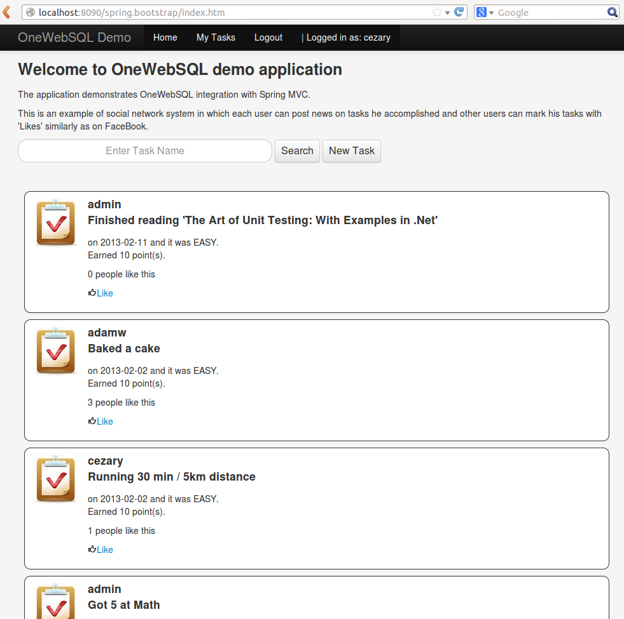

References:
1.http://onewebsql.com/docs/1_0_x/official/db2java-guide/db2java-guide.html
2. http://onewebsql.com/docs/1_0_x/official/query-language-guide/query-language-guide.html#toc7
3. https://github.com/OneWebSQL/onewebsql-workshop/wiki/Instrukcja
4. http://onewebsql.com/docs/1_0_x/official/transactions-guide/transactions-guide.html#toc3

